Redesigning Alexa to maintain Attendance system

Raghavee E M G. Kalaiarasi Joshna Irene

UG Scholar Associate Professor UG Scholar

Department of CSE Department of CSE Department of CSE

Sathyabama Institute of Science Sathyabama Institute of Science Sathyabama Institute of Science

and Technology and Technology and Technology

Chennai, India Chennai, India Chennai, India

[raghaveemani20@gmail.com](mailto:raghaveemani20@gmail.com) [kalaiarasi.cse@sathyabama.ac.in](mailto:kalaiarasi.cse@sathyabama.ac.in) [jo21112001.irene@gmail.com](mailto:jo21112001.irene@gmail.com)

***Abstract***

***To enhance the user experience and expand the capabilities of the devices being used, intelligent voice assistants are encroaching on numerous industries. They are being deployed in a variety of devices, from mobile phones to standalone units that only house the assistant for smart devices integration. The exponential expansion, the effect it has had on society, and the expanding applications they may be employed for make this abundantly evident. The research described in this paper tries to include one of Amazon's well-known voice assistants, Alexa, to update the traditional approaches to an attendance system. The teacher issues a cue to the assistant, approving the commencement of the attendance procedure. The student feedback for the revision of is then presented. This facilitates the digitalization of the attendance data all at once, saving the user time and effort***.

***Keywords*** – *Alexa, Attendance system, NodeMCU****,***[*4-Channel Relay Board*](http://amzn.to/2kL6C4w)*, ARDUINO IDE .*

i. INTRODUCTION

Virtual voice assistants have advanced significantly from doing easy tasks and responding to user-level enquiries. Natural learning training algorithms have expanded in terms of their application domains and degree of automation along with the development and integration of voice recognition. They are being increasingly used in conjunction with devices boasting of wireless connection capabilities. Their cognitive powers are growing, and as a result, they can now handle increasingly complex requests from their consumers. Some of the more popular ones in the market are:

• Alexa, from Amazon

• Cortana, from Microsoft

• Siri, from Apple

• Google Assistant, from Google

Alexa performs tasks given to it, with the help of its skill set, which consists of a set of skills to react upon every task submitted to it. Each talent has its own invocation phrase, which Alexa uses to transfer the assignment to that skill. The skill then carries out the operation in accordance with its test utterances by connecting to the endpoint on a server, which could be

hosted by Amazon Web Services (AWS) Lambda or a local server within the user's network. Alexa-based attendance tracking has a number of benefits, including accuracy, usability, time savings, increased productivity, and ease of use.

ii. LITERATURE SURVEY

All organizations need an attendance management system to maintain a record of their staff attendance either manually or automatically[13]. Students’ daily attendance in class is essential for performance evaluation and quality monitoring. Calling names or signing on papers are the traditional methods used in most organizations, which are both time consuming and insecure. On the other hand, most automatic human identification systems are based on traditional methods such as fingerprints, passwords, and ID scans. However, all these methods have several limitations such as forgetting a password or losing an ID card. Therefore, the most suitable method to ensure full security and to save history records is through a smart face recognition system.

It is a rapidly growing field in the recent time, and it plays an important role in security as it is a very precise technique to identify and verify people. Transfer learning is a form of machine learning where a model is built for a specific task and then reused on a second task as the starting point to be modified. It is used in deep learning as a pre-trained model in computer vision and natural language processing tasks to develop neural network models on these problems. Transfer learning is very useful in deep learning problems because most real-world problems usually have billions of labeled data, and this requires complex models. It is a perfect technique for optimization, time saving and achieving better performance. Developers can use transfer learning to merge different applications into one. They can quickly train new models for complex applications. Moreover, transfer learning is a good tool to improve the accuracy of computer vision models .

Manual attendance has been carried out for many years which is time consuming and also provides erroneous results[11]. The faculty has to maintain the attendance record in registers and file using pen and paper. With the development in technology, we have to look for an automated way for managing attendance. Using mobile phones provide an alternative way in this direction. The proposed system helps the teaching faculty members to maintain attendance of each class they handle. The attendance is recorded using voice automation and then updated in the database maintained for the attendance. The system also enables the teacher to mail periodic reports of the student to their parents. Thus it bridges the communication gap between the faculty members and the parents.The attendance system is one of the most important systems used in every educational institution to track the presence of a student in the institution. The manual method followed for taking attendance needs a lot of paper work and was tiresome. Since the system was not automated and requires manual work, maintaining the system was difficult. It needed the faculty to give the attendance details for uploading in the server. But if the attendance system is automated, the manual effort needed in storing the records and maintaining it can be reduced. It is easy to use the fully automated attendance system through mobile devices and take attendance which does not need any external effort to store and upload the attendance in the server. Since android mobile phones are being extensively used by the educators, this system is developed as an android application.

Tracking student attendance and assets are two important problems in most universities since these are parts of the evaluation process for students and annual audits for university assets[12]. While there are many methods in the literature to solve the student and assets tracking, we choose barcode technology because it is cheap and easy to implement. In this paper, we start with a historical overview of the beginning of the use of barcode technology and identifying some of its types. Bernard Silver and Norman Joseph Woodland invented the first optically scanned barcode, introduced the first-ever barcode, which looks like a bullseye. In 1952, they developed the barcode and reduced the cost of the system and registered a patent. Later, they developed solutions to automatically read product information during grocery checkout for the food chain Food Fair. Since then, the barcode project has widely spread. In the 1970s, a Universal Product Code (UPC) was scanned for the first time at a grocery store market in the United States. The automotive industry and US Department of Defense (DoD) adopted another barcode standard, the Code 39 Nowadays, barcodes are used on most goods and materials. The barcode technology’s key features are easy to use, low cost, and its widespread use in various fields including products and services. Barcode technology uses optical scanners to read data such as numbers, letters, images, and locations. It can be a one-dimensional code or two-dimensional code. One-dimensional code is designed in the form of black rectangle bars called barcode with limited features. However, two-dimensional code is designed as boxes, hexagonal shapes, and other geometric shapes with many features.Automatic Identification and Data Capture (AIDC) represents a group of technologies that support direct data entry into a computer without using a keyboard. AIDC technologies can improve accuracy, efficiency and reduce the time required for identification, marking and data collection . Almost all the AIDC technologies are comprised of three principal components: (1) data encoder, (2) machine reader or scanner, and (3) data decoder [4]. The data encoder converts alphanumeric characters into machine-readable code whereas the machine reader or scanner reads the encoded data and transforms it into an analog electrical signal. Finally, the data decoder converts the electrical signal into digital form and then into an original alphanumeric characters data form. The AIDC technologies have been successfully applied in the manufacturing, retail, and logistics industry . However, their implementation in the education sector is not that common. The authors view this as a great opportunity for the education sector, where these technologies can be applied to automate a wide range of activities, including student attendance and asset tracking.

iii. PROPOSED WORK

1. ***Hardware Requirements***

To build this project you will need the following

hardware as shown in Fig.1.

* [Amazon Echo Dot](http://amzn.to/2h55l6Q)
* [NodeMCU Development Board](http://amzn.to/2lS4ic5)
* [4-Channel Relay Board](http://amzn.to/2kL6C4w)
* [20x4 I2C Character LCD](http://amzn.to/2kL1zBg)
* [Dupont Style Jumper Wires](http://amzn.to/2kqZ62M)
* [Bread Board](http://amzn.to/2l9bqBI)

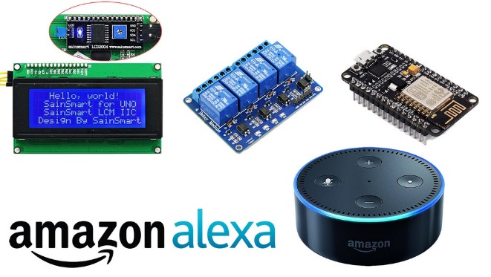

Fig.1. Hardware components

1. ***Software Components***

To complete this project, you will need the following

software and documentation.

* [Arduino IDE](https://www.arduino.cc/en/Main/Software)
* [FauxMos Source Code](https://github.com/CharlesJGantt/NodeMCU-ESP8266-4-Channel-Relay-Board-Controlled-by-Amazon-Alexa)
* [NodeMCU Documentation](http://www.nodemcu.com/index_en.html)

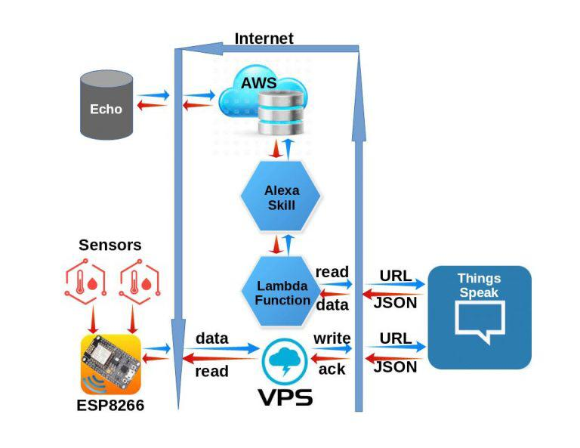

Fig.2. Block Diagram of the setup

IV. WORKPLAN

The architecture of the system is shown in Fig.3. .

The following is how the project succeeds in its goal:

* The teacher turns on the Echo Dot before giving the instruction to initiate the connection to the server running the excel sheet.
* The teacher is required to authenticate his presence by giving his/her identity and once the connection has been made.
* If the validation is successful, this causes the excel sheet to open the attendance database that is contained in the excel sheet linked to the teacher's name.
* The specific column is subsequently produced after the teacher gives the day's session number. This is to indicate that if the same teacher taught more than one class on the same day, a different column will be added to the record.
* The next step is for each student to speak their or her unique identifying number (UIN) to the gadget in order to verify their presence.
* This keeps going until the final pupil changes his or her attendance.
* After receiving the UIN and the status, the server updates the records that are already there.
* The necessary sequence of data is transmitted to the server hosted over the created tunnel after each student's command is translated and translated.

The way the model works :

1. The echo dot is initiated and accesses the internet in order to connect to the Amazon skill set on the AWS portal.
2. The skill set used on Amazon is further modified in the portal to collect and process the data
3. The lambda function reads the data that connects to the URL to connect with think speak. It is to run codes.
4. on high availability computer infrastructure and perform all the administration of computer resources, including servers and, operation system maintenance, capacity provisioning and automatic scaling, and logging.
5. The collected information is stored and accessed through the internet via think speak as it enables the sensors and websites to access and store it in private or public channels.
6. The data is further acknowledged by the stored data in the virtual private server (vps).

The working of project can be broken down into the

following modules:

1. ***Alexa***

One of the key elements of this project is Alexa, an Amazon speech assistant that sits on the Amazon Echo Dot. This module captures and automates the data that is voice-instructed to it. It responds to commands given to the device verbally. As the first command to connect to the server and start the attendance process, the teacher will issue the initiating command. The unique identification number (UIN) will be returned to the server in response to subsequent commands***.***

1. ***NodeMCU***

NodeMCU is an open source IoT platform that consists of hardware based on the ESP-12 module and firmware that runs on the ESP8266 Wi-Fi SoC from Espressif Systems. By default, the NodeMCU firmware employs the Lua scripting language, which was created using the Espressif Non-OS SDK for ESP8266 and is based on the eLua project. It makes extensive use of open source programmes like lua-cjson and spiffs.

***C. NODEMCU + ARDUINO IDE HOME AUTOMATION.***

The ARM/SAM MCU, which is used in the Arduino, and other non-AVR processor-based MCU boards were being developed by Arduino.cc at the time. Owing to this, they had to adapt the Arduino IDE to make it relatively simple to support other tool chains and enable the compilation of Arduino C/C++ to these new processors. They accomplished this by introducing the SAM Core and the Board Manager. A "core" is a group of software tools needed by the Board Manager and the Arduino IDE to translate an Arduino C/C++ source file into the machine language of the intended MCU. An Arduino core for the ESP8266 WiFi SoC has been created by a number of inventive ESP8266 fans and is accessible at the GitHub ESP8266 Core webpage.

This is referred to as the "ESP8266 Core for the Arduino IDE" in the popular press, and it has emerged as one of the top software development environments for the numerous ESP8266-based modules and development boards, including NodeMCUs

V. RESULTS AND DISCUSSION

Our lives are becoming easier and simpler as a result of the rapid advancement of technology. Though there are many methods to digitalize the method of marking attendance by a teacher, none of them are predominant compared to the customary method of maintaining an attendance register. If the old procedures are still used, the current requirement for attendance records to be in a digital format represents an unavoidable overhead. The suggested approach eliminates the teacher's overhead and is user-friendly. This prototype aids in solving the challenges facing the current attendance system. The voice recognition system that is suggested in this paper can be coupled with the university's education system to automatically gather and update attendance and asset tracking data, allowing for further website portal access if the university management chooses to use it. Instructors, students, and the university administration can all access the database as a resource for information.

##### VI.CONCLUSION.

The current attendance system was implemented over a number of years. The current attendance method in the educational sector requires excess man power inorder to take attendance, which means it takes too long to filter student data according to different criteria.

The proposed system has demonstrated its effectiveness in recording student attendance while requiring the least amount of manual labor for data organization and sorting. Digitalizing the attendance system has also shown to be more beneficial to the faculty since it requires less labor to sort data than the current system does. Future iterations of the proposed project's scope may include speech recognition technology for proxy identification during marking attendance. The project's efficiency could be increased by developing an online gateway for the attendance system rather to the google sheet that is currently used for displaying data for attendance. Instructors, students, and the university administration can all access the database as a resource for information for easy access.

VI. REFERENCES

[1] Amazon Alexa Skill Store: <https://amazon.com/skills>

[2] Alexa Now Has Over 10,000 Skills Available, Amazon’s Developer Blog, Feb 23, 2017.

[3] C. Z. Yue and S. Ping, "Voice activated smart home design and implementation," 2017 2nd International Conference on Frontiers of Sensors Technologies (ICFST), Shenzhen, 2017, pp. 489-492. doi: 10.1109/ICFST.2017.8210563

[4] ngrok, ngrok working, <https://ngrok.com/product>

[5] Foundation, Raspberry Pi, Raspberry Pi 3 Model B specifications.<https://www.raspberrypi.org/products/raspberry-pi-3-model-b/>

[6] J. D. Sweetlin, V. Aswini and R. Dhanusha, "Speech based attendance application register," 2016 International Conference on Recent Trends in Information Technology (ICRTIT), Chennai, 2016, pp. 1-5.

[7] S. Dey et al., "Speech biometric based attendance system," 2014 Twentieth National Conference on Communications (NCC), Kanpur, 2014, pp. 1-6.

[8]Request and Response JSON .

[9] Reference:https://developer.amazon.com/docs/custom-skills/request-and-responsejson-reference.html .

[10] Python Documentation: <https://docs.python.org/3/>

[11] SQLite Documentation: <https://www.sqlite.org/docs.html>.

[12] J. D. Sweetlin, V. Aswini and R. Dhanusha, "Speech based attendance application register," 2016 International Conference on Recent Trends in Information Technology (ICRTIT), Chennai, 2016, pp. 15***.***

[13]Salah Elaskari, “Using Barcode to Track Student Attendance and Assets in Higher Education Institutions” The 12th International Conference on Ambient Systems, Networks and Technologies (ANT) March 23-26, 2021, Warsaw, Poland.

[14] Mitha Alhammadia , Nahla Almenhalia "Face Recognition Smart Attendance System using Deep Transfer Learning" 2021 The Authors. Published by Elsevier B.V. Procedia Computer Science 192 (2021) 4093–4102.

.